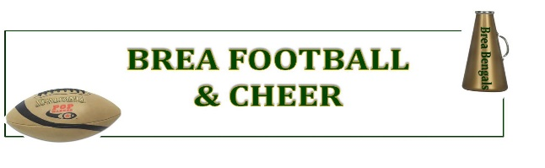
Platinum Sponsor: $1500 +
BJAA – Brea Pop Warner
2026 Corporate Sponsorship Packages
- League will provide a City Approved Sponsorship Banner at all Home Events (3’ x 6’)
- Top Tier Positioning on our BREAPOPWARNER.COM Sponsors page
- Banner or Print Inclusion in our BPW Promotions or Events
- Sponsorship Plaque
- Company name will be announced at our Opening Day Ceremonies.

Gold Sponsor: $1300 +
- League will provide City Approved Banner to be displayed at all Home Events (3’ x 6’)
- Upper Tier Link on our Website Sponsors Page
- Sponsorship Plaque
- You’ll know that you made a big difference to our kids!

ATTACH

BUSINESS

CARD

HERE
Silver Sponsor: $1000 +
- League will provide City Approved Banner to be displayed at
all Home Events (3’ x 4’)
- Upper Tier Link on our Website Sponsors Page
- Link on our Website Sponsors Page
- Sponsorship Plaque
- You’ll know that you made a big difference to our kids!

Bronze Sponsor: $700 +
- League will provide City Approved Banner to be displayed at
all Home Events (3’ x 4’)
- Link on our Website Sponsors Page
- You’ll know that you made a big difference to our kids!

Checks payable to Brea Junior Athletic Association
Your donation may be tax deductible as Brea Pop Warner Football and Cheer is registered as a 501(c) 3, not-for-profit organization. Our Tax ID number is: 95-3421459.

Check Amount: $700 $1000 $1300 $1500
Other Amount: $

Contact Fundraising Director, at breapopwarner@gmail.com with any questions.
Please attach your business card for our webmaster.
Sponsor / Company Name:
Person to Contact:
E-Mail Address:
Address:
City, State, Zip:
Telephone:


Brea Pop Warner & Cheer, P.O. Box 701, Brea, CA. 92822
breapopwarner@gmail.com

